**ONLINE EXAMINATION SYSTEM**

Table of Contents

1. Introduction 1

1.1. Project Overview 1

1.2. Purpose 1

1.3. Scope 1

1.4. Definitions, Acronyms 1

2. Functional or Specific Requirements 2

2.1. External Interface Requirements 4

2.1.1. Hardware Interfaces 4

2.1.2. Software Interface 4

2.1.3. Third Party Software Interfaces 4

2.1.4. Communication Protocol 4

2.1.5. Assumption and Dependency 5

2.2. Non-Functional Requirements 5

2.3. Software System Attributes 5

2.3.1. Browser Compatibility 5

2.3.2. Globalization Support 7

2.3.3. Security 8

2.3.4. Reliability 8

2.3.5. Availability 8

2.3.6. Portability 8

2.3.7. Performance 9

2.4. Database Requirements 9

2.5. Technologies 9

2.6. Software 9

2.7. Hardware 9

2.7.1. Server 9

2.7.2. Client 10

3. Analysis and Design 11

3.1. Use Case Diagram 11

3.1.1. Use case Overview 11

3.1.2. Add Faculty Use Case 12

3.1.3. Login Use Case 12

3.1.4. Manage Student Groups Use Case 13

3.1.5. Student Registration Use Case 13

3.1.6. User Profile Edit Use Case 14

3.1.7. Manage Test Use Case 15

3.1.8. Appear for Test Use Case 16

3.1.9. Generate Result Use Case 17

3.2. Activity Diagram 18

3.2.1. Login Activity Diagram 18

3.2.2. Manage Students Activity Diagram 19

3.2.3. Manage Tests Activity Diagram 20

3.2.4. Generate Result Activity Diagram 21

3.2.5. Student Registration Activity Diagram 22

3.2.6. Answer Test Activity Diagram 23

3.3. Sequence Diagrams 24

3.3.1. Sequence Diagram Overview 24

3.3.2. Login Sequence Diagram 25

3.3.3. Manage Student Groups Sequence Diagram 26

3.3.4. Student Registration Sequence Diagram 27

3.3.5. Manage Test Sequence Diagram 28

3.3.6. Appear for Test Sequence Diagram 29

3.4. Class Diagram 30

3.5. Database Design 31

3.5.1. Table: Student 32

3.5.2. Table: Test 32

3.5.3. Table: TestQuestions 32

3.5.4. Table: StudentResponse 33

3.5.5. Table: TestSession 33

3.5.6. Table: Groups 33

3.5.7. Table: Faculty 33

3.5.8. Table: AssignGroupTest 34

# 

# Introduction

## Project Overview

This project assesses students by conducting online objective tests. The tests would be highly customizable. This project will enable educational institutes to conduct test and have automated checking of answers based on the response by the candidates.

The project allows faculties to create their own tests. It would enable educational institutes to perform tests, quiz and create feedback forms. It asks faculty to create his/her set of questions. Faculty then creates groups and adds related students into the groups. Further the tests are associated with specific groups so that only associated students can appear for the test. The result of the response would be available to the faculty of the question set. Further the result would also be mailed to the student. This project would be helpful for creating practice tests, say for educational institutes and as a feedback form.

## Purpose

* Responses by the candidates will be checked automatically and instantly.
* Online examination will reduce the hectic job of assessing the answers given by the candidates.
* Being an integrated Online Examination System it will reduce paper work.
* Can generate various reports almost instantly when and where required.

## Scope

This project would be very useful for educational institutes where regular evaluation of students’ is required. Further it can also be useful for anyone who requires feedback based on objective type responses.

## Definitions, Acronyms

The sub-section provides the definitions of all terms, acronyms, and abbreviations used in this document to understand the SRS properly.

| **Sr. No.** | **Terms/Acronyms** | **Description** |
| --- | --- | --- |
|  | Student | User mostly a student who will appear for the examination |
|  | Faculty | Another user mostly faculty member, lecturer or examiner who posts set of questions, the available options and correct answers. |
|  | Administrator | Super user, adds faculty and manages system. |

# Functional or Specific Requirements

Required software is for conducting on-line `***objective****’* type examination and providing immediate results. The system should satisfy the following requirements:

* **Administrator Aspect**
  1. Taking backup of the database
  2. Editing/Deleting/Creating the database.
  3. Adding or expelling faculty
  4. Changing the super password.
* **Faculty Aspect**
  1. Logging into the system.
  2. Sending invitations to specific student by mail
  3. Accepting registrations of candidates
  4. Adding the candidate to a group
  5. Create/Edit/Delete candidate groups
  6. Creating a test
  7. Posting questions in the above test
  8. Posting multiple options to respective question
  9. Marking correct answer within the given options
  10. Specifying to allow user defined answer
  11. Time limit of the test if any.
  12. Whether to randomize the questions
  13. Whether to randomize the options displayed
  14. To allow the test to be taken in practice mode where the correct answer is shown immediately after the candidate selects an option.
  15. Set negative marks for wrong responses
* **Student Aspect:**
  1. Requesting registration
  2. Logging into the system.
  3. Edit user information.
  4. Selecting the test.
  5. Selecting whether the test to be taken in practice mode where the correct answer is shown immediately after the candidate selects an option.
  6. Appearing for the examination.
  7. Printing the result at the end of the examination.
  8. Reviewing the given responses.
  9. Changing password.
  10. Resetting of forgotten password
* **Analysis**
  1. Authenticating users based on username and password
  2. Keeping session track of user activity
  3. Recording candidates’ responses to every question
  4. Checking whether the given response is correct or not
  5. Keeping history of test reports of all users
* **Mailing**
  1. The reports are required to be mailed to the candidates on the registered mail address.
  2. Temporary password will be mailed to the user incase the user forgets the password.
  3. Invitations for the appearance for the new test will be mailed.

## External Interface Requirements

### Hardware Interfaces

**Server side hardware**

* + - * Hardware recommended by all the software needed.
      * Communication hardware to serve client requests

**Client side hardware**

* + - * Hardware recommended by respective client’s operating system and web browser.
      * Communication hardware to communicate the server.

### Software Interface

**Server side software**

* + - * Web server software, Apache Tomcat
      * Server side scripting tools: PHP
      * Database tools: Sedna native XML DBMS.
      * Compatible operating system: Windows/Linux

**Client side software**

* + - * Web browser supporting JavaScript, refer Browser Compatibility 2.3.1

### Third Party Software Interfaces

None

### Communication Protocol

Following protocols are required to be permitted on the server side

* HTTP incoming request
* HTTPS incoming request if secure gateway is implemented

Following protocols are required to be permitted on the client side

* HTTP outgoing request
* HTTPS outgoing request if secure gateway is implemented

### Assumption and Dependency

1. Username are valid email addresses of respective user
2. Administrator has the authority to add/delete faculty level accounts.
3. Faculty have the authority to approve/expel student
4. Faculty have the authority to change student’s group

### Non-Functional Requirements

* System should be able handle multiple users
* Database updating should follow transaction processing to avoid data inconsistency.

## Software System Attributes

### Browser Compatibility

The project being web based required compatibility with at least the popular web browsers. Microsoft Windows XP and above, Linux and Macintosh being the current popular operating system and Microsoft Internet Explorer, Mozilla Firefox, Opera, Safari and Google Chrome being the currently popular web browsers.

|  |  |  |  |  |  |  |  |
| --- | --- | --- | --- | --- | --- | --- | --- |
| **Operating System** | ***Win 2000*** | ***WinXP*** | ***WinXPSP2*** | ***Win Vista*** | ***Win 7*** | ***Mac OS*** | ***Linux*** |
| **Browsers** |
|  | ***Modern Browsers*** | | | | | | |
| ***IE 8.0*** | *N/A* | *SUPP* | *SUPP* | *SUPP* | *SUPP* | *N/A* | *N/A* |
| ***IE 7.0*** | *N/A* | *N/A* | *N/A* | *N/A* |  | *N/A* |  |
| ***IE 6.0*** | *N/A* | *N/A* | *N/A* | *N/A* |  | *N/A* |  |
| ***Firefox 3.5*** | *N/A* | *SUPP* | *N/A* | *N/A* |  | *N/A* |  |
| ***Opera 9.23*** | *N/A* | *SUPP* | *N/A* | *N/A* |  | *N/A* |  |
| ***Safari 9.27*** | *N/A* | *SUPP* | *N/A* | *N/A* |  | *SUPP* |  |
|  | ***“Legacy” Old Browsers*** | | | | | | |
| ***IE5.5*** | *N/A* | *N/A* | *N/A* | *N/A* |  | *N/A* |  |
| ***Netscape*** | *N/A* | *N/A* | *N/A* | *N/A* |  | *N/A* |  |

### Globalization Support

The questionnaires and their respective options provided by the faculty may or may not be in English. Hence the questions and their options must be in Unicode format that will accept any Unicode character.

#### List of Locale

The system will mostly be in US English, although the questions and their options may not be in US English. Hence the questions and their options are to be in Unicode format.

|  |  |  |  |  |  |
| --- | --- | --- | --- | --- | --- |
| **Locale** | **Date Format** | **Time Format** | **Currency Format** | **Calendar** | **Character Set** |
| en-US | Use Default | Use Default | Use Default | Use Default | SBCS |
| Non en-US | dd-MM-yy | HH:mm:ss | Use Default | d-MM-yyyy | MBCS/Unicode |

#### Content to be localized

The following table lists all the possible area in the system and also mentions whether that area should support Globalization.

|  |  |
| --- | --- |
| **Interface Type** | **Needs Localization?** |
| User Interface | Yes* |
| Emails sent by system, | Yes* |
| Standard Errors and exceptions logged by system in error log | No |
| Logos, Images | No |
| Unit of Measurement ( Ex. Length, Weight, Area, Volume, Paper Size etc) | No |
| Reports | Yes* |

*Limited to questionnaires set by user who posted questions.

### Security

* Administrator has the highest authority to edit/delete/create database
* Faculty have the authority to add/expel students
* Students can only view their test records.
* Faculty can view all the test records of every student.
* Critical information like passwords should be transferred in encrypted form
* Passwords should be stored in encrypted form
* Password will not be mailed to the user in case user forgets password, instead either temporary password or a password reset link will be sent.

### Reliability

Data validation and verification needs to be done at every stage of activity.

* Validating user input
* Use of locking mechanism while updating database like transaction processing
* Recovering the transaction using rollback.

### Availability

The examination system being an online system should be available anytime.

**Constraints**:

Though the system should be available 24x7 some features may be restricted.

* Quiz creator may allow the specific test to be available only at certain time like scheduled examination.
* The test may be time limited so the candidates appearing will have limited time to answer the test.

### Portability

* The web application will be built using PHP which has support to run on any platform provided the required compilers are available.
* For database either XML or MySQL would be used, that too has extensive support over many popular architectures and operating systems.

**Constraints**:

Portability would be limited to the support provided by the respective application vendor on various architectures and operating environments.

### Performance

The system would be used by multiple users at a time and may grow as time passes; the system would need to implement multithreading to achieve acceptable performance. Further a database connection pool may also be required for assigning faster database connection.

## Database Requirements

Database fields for questions and respective options must be in Unicode format to handle non English characters

## Technologies

This section lists all the technologies for the web based system.

* PHP scripting for server side scripting as it has a very strong support for XML and MySQL.
* XML as database format: The database’ performance requirements are not very high and the ability to have custom fields in case the quiz creator needs to add more than expected answer options. This is limited in any other database management system where we have to first specify the maximum number of fields.
* Apache as web server has a tight integration with PHP and is also available for various popular platforms.

## Software

Netbeans or Eclipse for PHP and XML coding.

Apache Tomcat as Web server

## Hardware

The recommended hardware specified by the respective software would suffice the needs. The memory and processing power needed would increase as the number of users increase. The estimated hardware requirements are as specified.

### Server

The minimum hardware as recommended by all of the software required on server side say web server, operating system and development software

* Processing speed of 1.6 GHz
* 1 GB of RAM
* Network interface

### Client

The minimum hardware as recommended by all of the software required on client side say web browser, operating system

* Minimum hardware depending on the operating system used
* True color visual display unit
* User peripherals for better interaction

# Analysis and Design

## Use Case Diagram

### Use case Overview

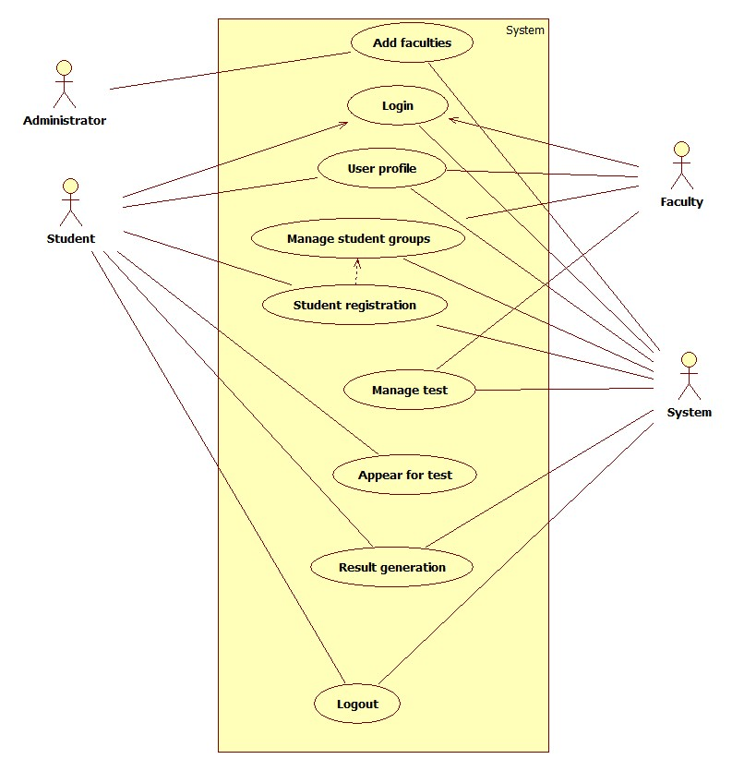

### Add Faculty Use Case

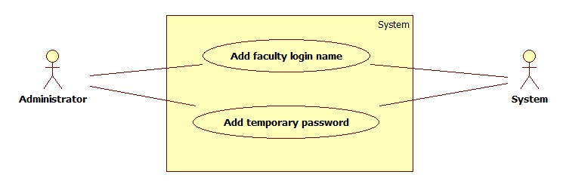

### Login Use Case

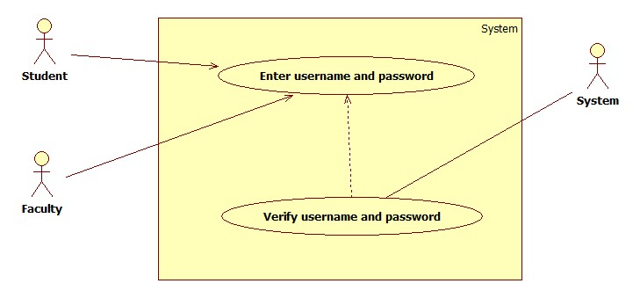

### Manage Student Groups Use Case

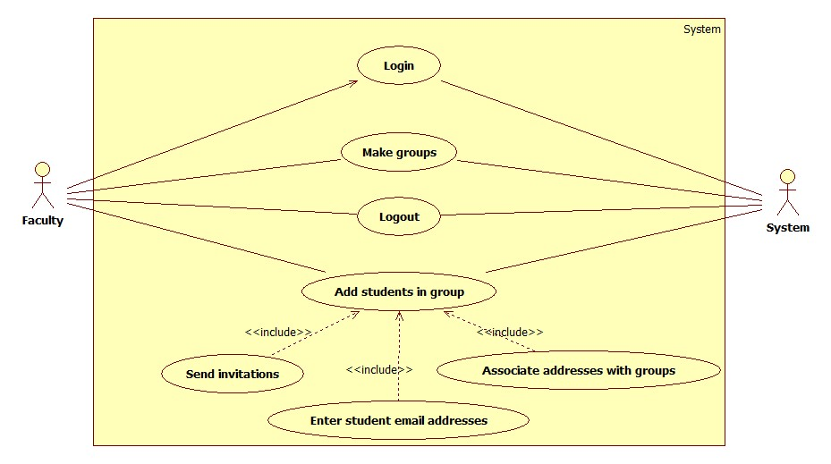

### Student Registration Use Case

`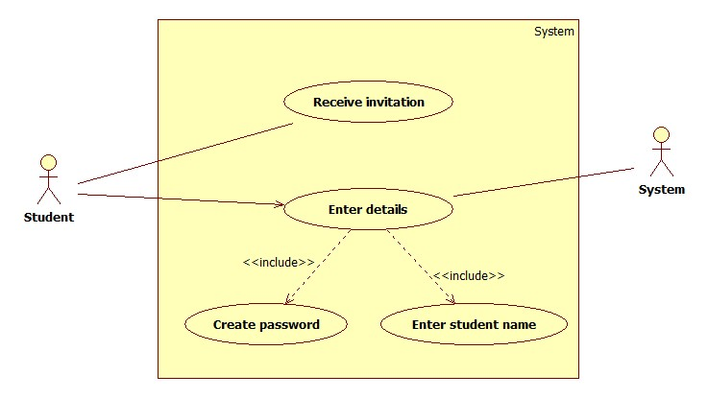

### User Profile Edit Use Case

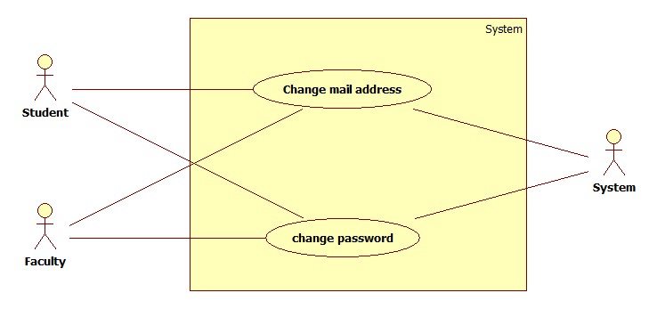

### Manage Test Use Case

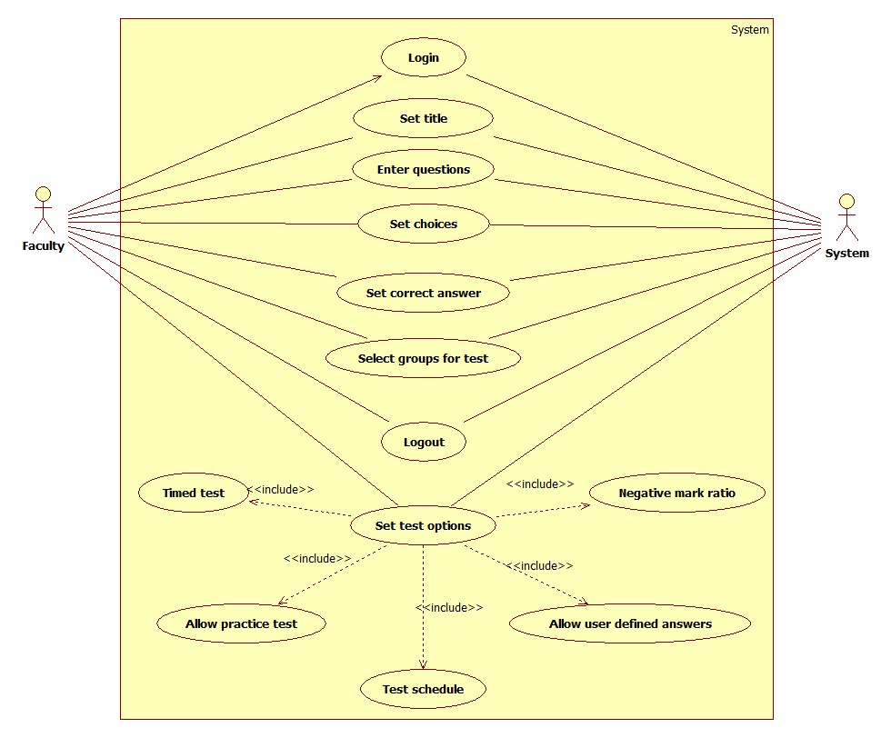

### Appear for Test Use Case

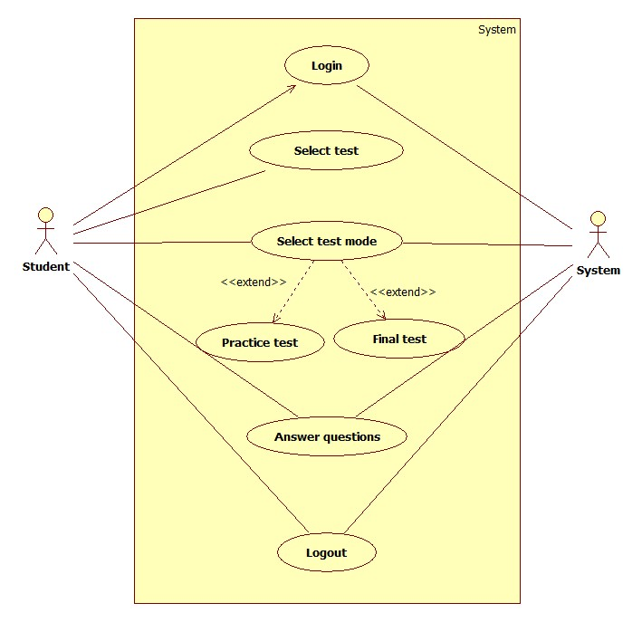

### Generate Result Use Case

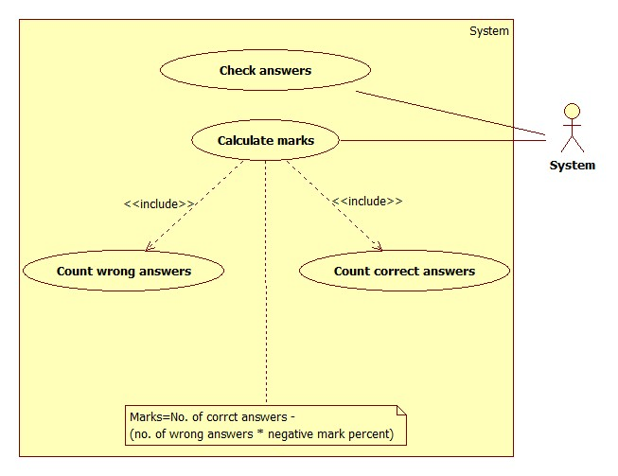

## Activity Diagram

### Login Activity Diagram

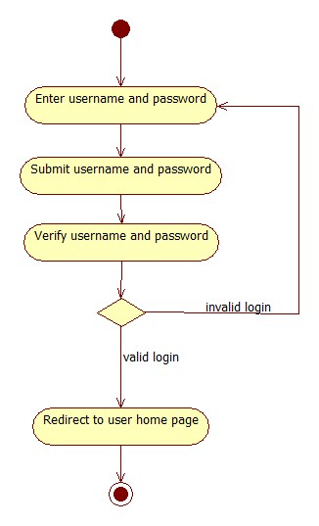

### Manage Students Activity Diagram

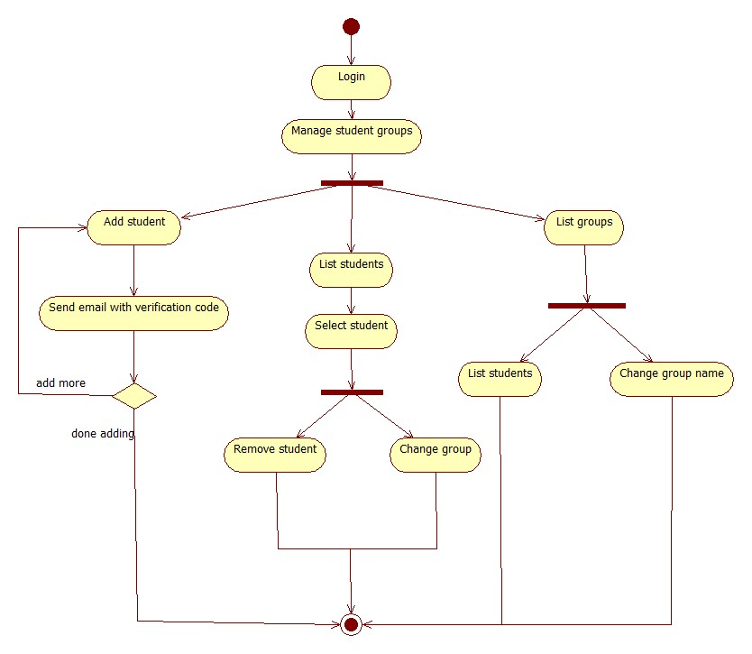

### Manage Tests Activity Diagram

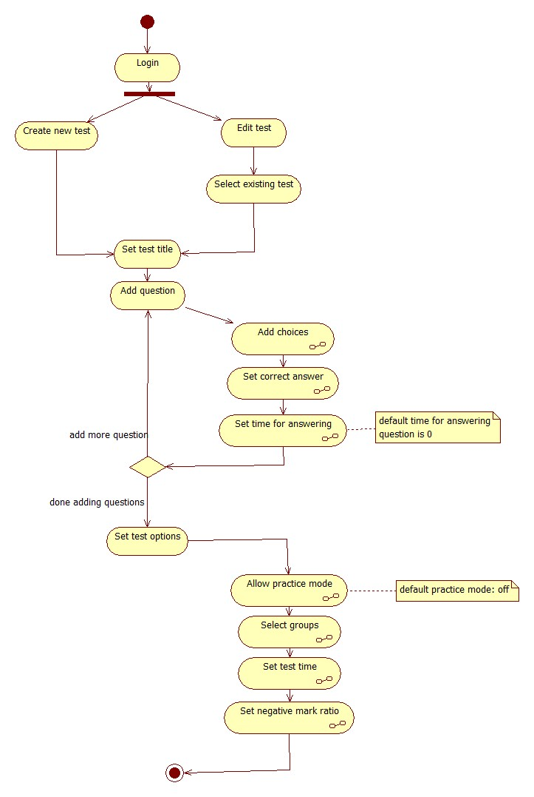

### Generate Result Activity Diagram

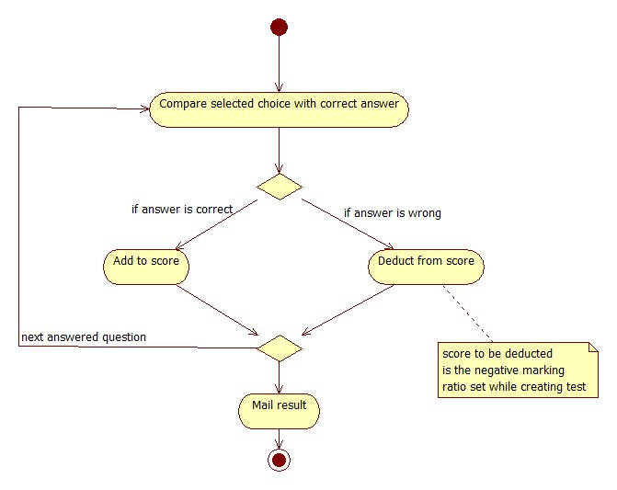

### Student Registration Activity Diagram

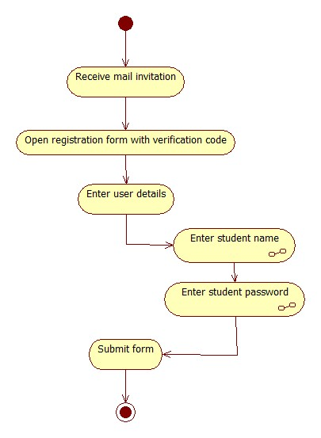

### Answer Test Activity Diagram

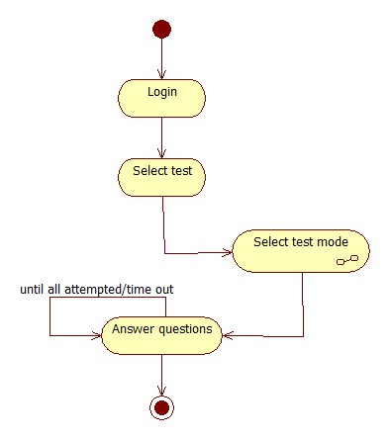

## Sequence Diagrams

### Sequence Diagram Overview

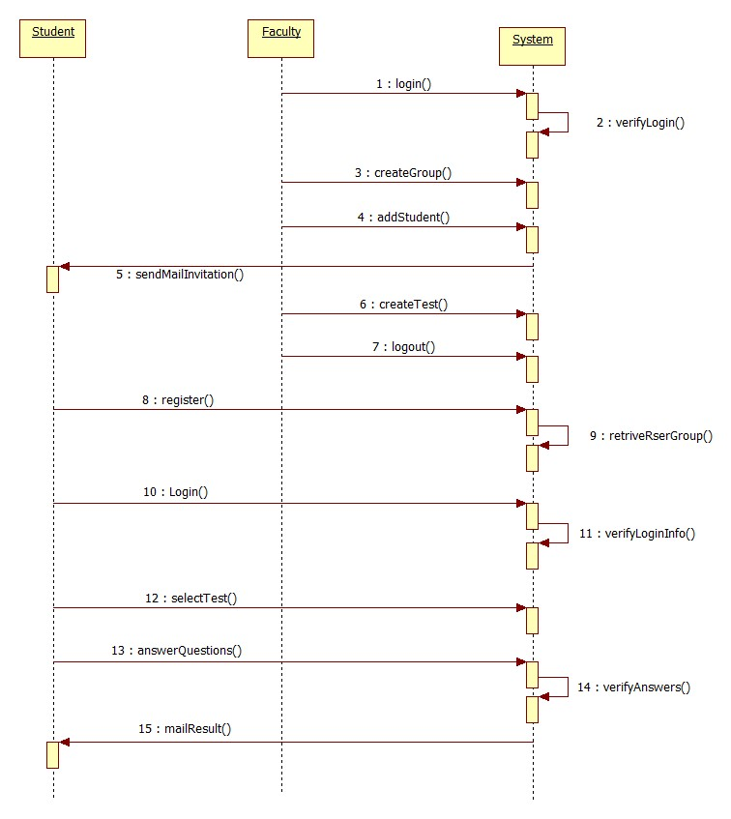

### Login Sequence Diagram

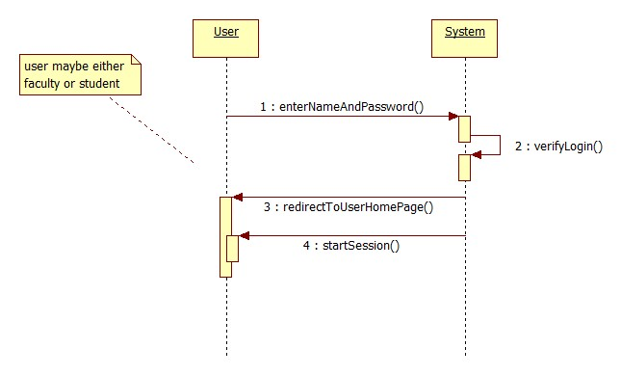

### Manage Student Groups Sequence Diagram

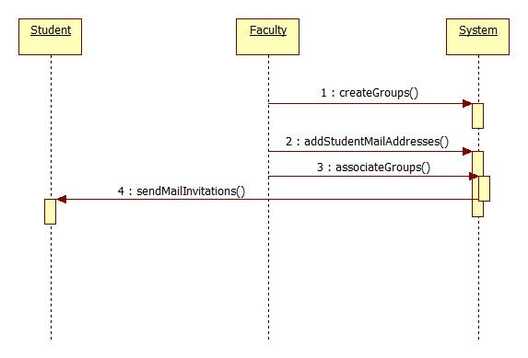

### Student Registration Sequence Diagram

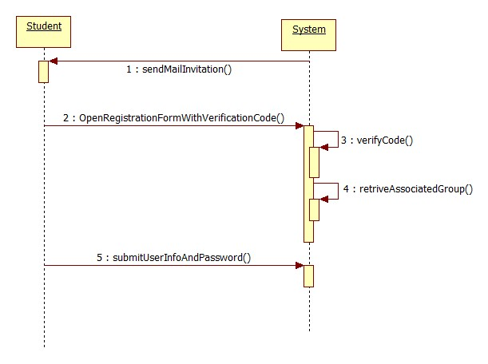

### Manage Test Sequence Diagram

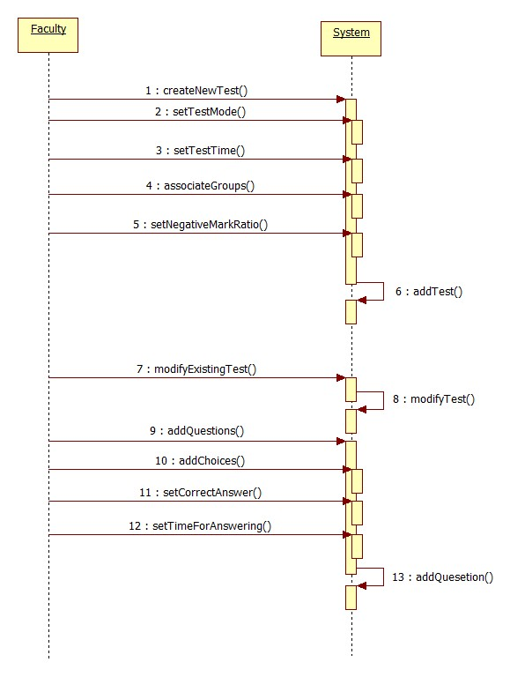

### Appear for Test Sequence Diagram

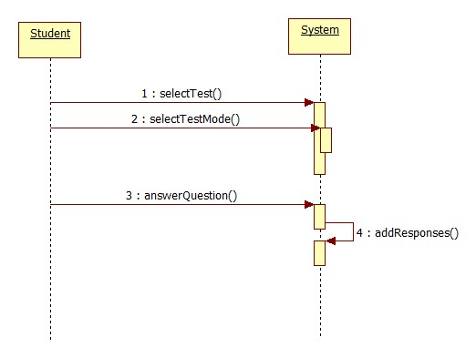

## Class Diagram

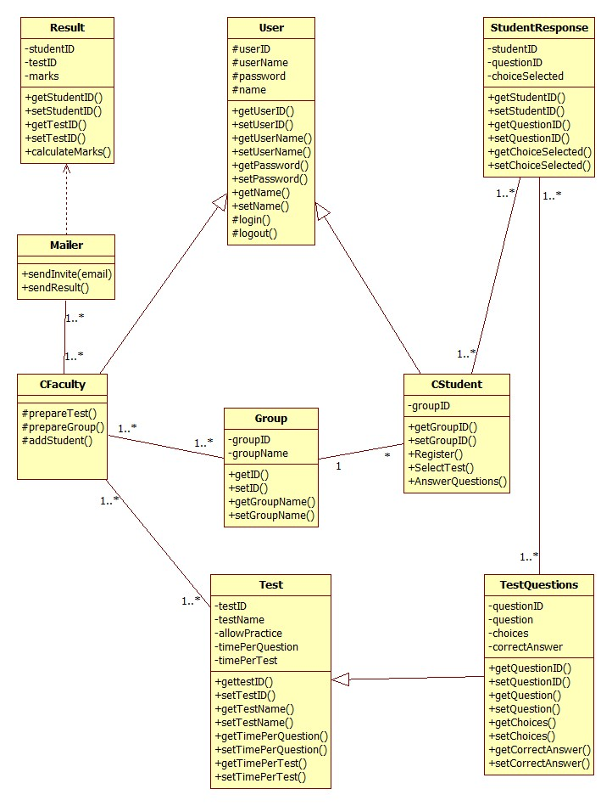

## Database Design

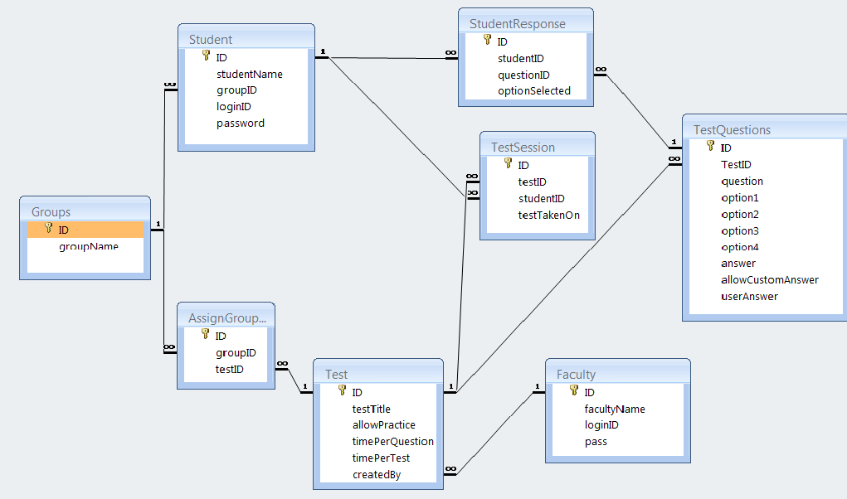

### Table: Student

|  |  |  |
| --- | --- | --- |
| **Field Name** | **Data Type** | **Constraints/Description** |
| ID | Unsigned Integer | Primary Key, AutoIncrement |
| studentName | Varchar2 |  |
| groupID | Unsigned Integer | Foreign:Groups.ID |
| loginID | Varchar2 |  |
| password | Varchar2 |  |

### Table: Test

|  |  |  |
| --- | --- | --- |
| **Field Name** | **Data Type** | **Description** |
| ID | Unsigned Integer | Primary Key, AutoIncrement |
| testTitle | Varchar2 |  |
| allowPractice | Yes/No |  |
| timePerQuestion | Unsigned Integer | in seconds, infinite if zero |
| timePerTest | Unsigned Integer | in minutes, infinite if zero |
| createdBy | Unsigned Integer | Foreign:Faculty.ID |

### Table: TestQuestions

|  |  |  |
| --- | --- | --- |
| **Field Name** | **Data Type** | **Description** |
| ID | Unsigned Integer | Primary Key, AutoIncrement |
| TestID | Number | Foreign:Test.ID |
| question | Varchar2 |  |
| option1 | Varchar2 | atleast two choices are required, hence this field is required |
| option2 | Varchar2 | atleast two choices are required, hence this field is required |
| option3 | Varchar2 |  |
| option4 | Varchar2 |  |
| answer | Unsigned Integer |  |
| allowCustomAnswer | Boolean |  |
| userAnswer | Varchar2 |  |

### Table: StudentResponse

|  |  |  |
| --- | --- | --- |
| **Field Name** | **Data Type** | **Description** |
| ID | Unsigned Integer | Primary Key, AutoIncrement |
| studentID | Unsigned Integer | Foreign:Student.ID |
| questionID | Unsigned Integer | Foreign:TestQuestions.ID |
| optionSelected | Unsigned Integer | if student does not answer, entry will not be made in db |
| customAnswer | Varchar2 | only if optionSelected field is 0 |

### Table: TestSession

|  |  |  |
| --- | --- | --- |
| **Field Name** | **Data Type** | **Description** |
| ID | Unsigned Integer | Primary Key, AutoIncrement |
| testID | Unsigned Integer | Foreign:Test.ID |
| studentID | Unsigned Integer | Foreign:Student.ID |
| testTakenOn | Date/Time | field required |

### Table: Groups

|  |  |  |
| --- | --- | --- |
| **Field Name** | **Data Type** | **Description** |
| ID | Unsigned Integer | Primary Key, AutoIncrement |
| groupName | Unsigned Integer |  |

### Table: Faculty

|  |  |  |
| --- | --- | --- |
| **Field Name** | **Data Type** | **Description** |
| ID | Unsigned Integer | Primary Key, AutoIncrement |
| facultyName | Varchar2 |  |
| loginID | Varchar2 |  |
| pass | Varchar2 |  |

### Table: AssignGroupTest

|  |  |  |
| --- | --- | --- |
| **Field Name** | **Data Type** | **Description** |
| ID | Unsigned Integer | Primary Key, AutoIncrement |
| groupID | Unsigned Integer | Foreign:Groups.ID |
| testID | Unsigned Integer | Foreign:Test.ID |